Module Design Document
For
ES34E_ePWM Subsystems
Ap_ePWM2

VERSION: 2.0
DATE: 04-29-2016

Prepared By:
Future Engineering Group,
Nexteer Automotive,
Saginaw, MI, USA
Location: The official version of this document is stored in the Nexteer Configuration Management System.

Revision History

Sl. No. | Description | Author | Version | Date
1 | Initial Version | Yue Zhao | 1.0 | 06-19-2015
2 | Updated for the variable name changes | Avinash James | 2.0 | 04-29-2016

Table of Contents
1 Abbrevations And Acronyms 5
2 References 6
3 ePWM Subsystems and use & High-Level Description 7
4 Design details of software module 8
4.1 Graphical representation of AP_epwm2 8
4.2 Data Flow Diagram 8
4.2.1 Module level DFD 8
4.2.2 Sub-Module level DFD 8
4.3 COMPONENT FLOW DIAGRAM 8
5 Variable Data Dictionary 9
5.1 User defined typedef definition/declaration 9
5.2 Variable definition for enumerated types 9
6 Constant Data Dictionary 10
6.1 Program(fixed) Constants 10
6.1.1 Embedded Constants 10
6.1.1.1 Local 10
6.1.1.2 Global 10
6.1.2 Module specific Lookup Tables Constants 10
7 Software Module Implementation 11
7.1 Sub-Module Functions 11
7.2 Initialization Functions 11
7.2.1 Init: <ModuleName>_Init 11
7.2.1.1 Design Rationale 11
7.2.1.2 Module Outputs 11
7.2.1.3 Module Internal 11
7.3 PERIODIC FUNCTIONS 11
7.3.1 Per: ePWM2_Per1 11
7.3.1.1 Design Rationale 11
7.3.1.2 Store Module Inputs to Local copies 11
7.3.1.3 Processing of function 12
7.3.1.4 Store Local copy of outputs into Module Outputs 12
7.4 Non PERIODIC FUNCTIONS 12
7.4.1 NONPer: <ModuleName>_NONPer<n> 12
7.4.1.1 Design Rationale 12
7.4.1.2 Store Module Inputs to Local copies 12
7.4.1.3 Processing of function 13
7.4.1.4 Store Local copy of outputs into Module Outputs 13
7.5 Interrupt Functions 13
7.5.1 Isr: <ModuleName>_Isr<n> 13
7.5.1.1 Design Rationale 13
7.5.1.2 (Processing of the ISR function)….. 13
7.6 Serial Communication Functions 14
7.6.1 SComm: <MODULENAME> 14
7.6.1.1 Design Rationale 14
7.6.1.2 Store Module Inputs to Local copies 14
7.6.1.3 Processing of function 14
7.6.1.4 Store Local copy of outputs into Module Outputs 14
7.7 Local Function/Macro Definitions 14
7.7.1 Local Function #1 14
7.7.1.1 Description 14
7.8 GLObAL Function/Macro Definitions 14
7.8.1 GLObAL Function #1 14
7.8.1.1 Description 14
7.9 TRANSIENT FUNCTIONS 14
7.9.1 Per: ePWM2_Trns1 14
7.9.1.1 Design Rationale 14
7.9.1.2 Store Module Inputs to Local copies 14
7.9.1.3 Processing of function 15
7.9.1.4 Store Local copy of outputs into Module Outputs 15
7.9.2 Per: ePWM2_Trns2 15
7.9.2.1 Design Rationale 15
7.9.2.2 Store Module Inputs to Local copies 15
7.9.2.3 Processing of function 15
7.9.2.4 Store Local copy of outputs into Module Outputs 15
8 Known Limitations With Design 16
9 UNIT TEST CONSIDERATION 17
10 Appendix 18

Abbrevations And Acronyms
Abbreviation | Description
DFD | Design functional diagram
MDD | Module design document
FDD | Functional design document

References
This section lists the title & version of all the documents that are referred for development of this document
Sr. No. | Title | Version
1 | MDD Guidelines | 1.4
2 | Software Naming Conventions | 2.0
3 | FDD: 34E - ePWM Subsystems | 001

ePWM Subsystems and use & High-Level Description

This module implements the ”Motor Control Configuration Override” subfunction of ES-34E. It controls enable and disable of the motor control ePWM outputs.

Design details of software module

Graphical representation of AP_epwm2
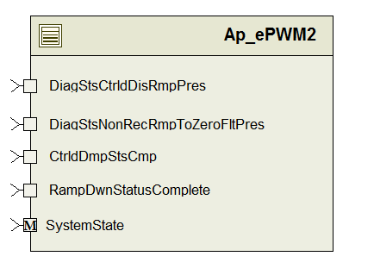

Data Flow Diagram
None

Module level DFD
None

Sub-Module level DFD
None

COMPONENT FLOW DIAGRAM
None

Variable Data Dictionary

User defined typedef definition/declaration
<This section documents any user types uniquely used for the module.>

Typedef Name | Element Name | User Defined Type | Legal Range  (min) | Legal Range  (max)
None

Variable definition for enumerated types
Enum Name | Element Name | Value
None

Constant Data Dictionary

Program(fixed) Constants

Embedded Constants

Local

Global

Constant Name
None

Module specific Lookup Tables Constants

Constant Name | Resolution | Value | Software Segment
None

Software Module Implementation

Sub-Module Functions
None

Initialization Functions

Init: <ModuleName>_Init

Design Rationale
None

Module Outputs
None

Module Internal

PERIODIC FUNCTIONS

Per: ePWM2_Per1

Design Rationale
implements the "ePWM Control Shutdown" portion of "Motor Control Configuration Override" Subfunction; this part of the subfunction runs periodically, while the remainder of the subfunction is implemented by two transition functions.
ES-34E specifies a NOR gate which disables the ePWM outputs when the NOR gate output is 0. This is simplified in the code by checking the OR condition and disabling outputs when the OR condition is true.

Store Module Inputs to Local copies

DiagStsCtrldDisRmpPres_Cnt_T_lgc = Rte_IRead_ePWM2_Per1_DiagStsCtrldDisRmpPres_Cnt_lgc()
DiagStsNonRecRmpToZeroFltPres_Cnt_T_lgc = Rte_IRead_ePWM2_Per1_DiagStsNonRecRmpToZeroFltPres_Cnt_lgc()
RampDwnStatusComplete_Cnt_T_lgc = Rte_IRead_ePWM2_Per1_RampDwnStatusComplete_Cnt_lgc()

CtrldDmpStsCmp_Cnt_T_lgc = Rte_IRead_ePWM2_Per1_CtrldDmpStsCmp_Cnt_lgc()

Processing of function

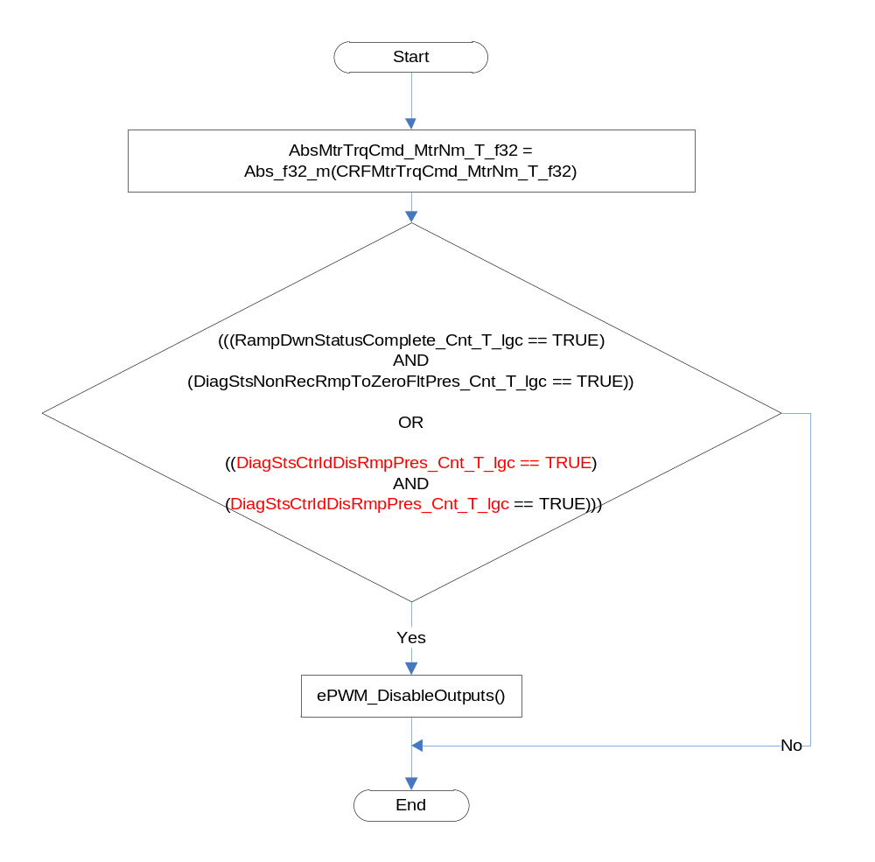

Store Local copy of outputs into Module Outputs
None

Non PERIODIC FUNCTIONS

NONPer: <ModuleName>_NONPer<n>

Design Rationale
None

Store Module Inputs to Local copies
None

Processing of function
None

Store Local copy of outputs into Module Outputs
None

Interrupt Functions

Isr: <ModuleName>_Isr<n>
None

Design Rationale
None

(Processing of the ISR function)…..
None

Serial Communication Functions

SComm: <MODULENAME>
None

Design Rationale
None

Store Module Inputs to Local copies
None

Processing of function
None

Store Local copy of outputs into Module Outputs
None

Local Function/Macro Definitions

Local Function #1
None

Description
None

GLObAL Function/Macro Definitions

GLObAL Function #1
None

Description
None

TRANSIENT FUNCTIONS

Per: ePWM2_Trns1

Design Rationale
Implements the "ePWM gate outputs are enable ON entering to operate state" portion of ES-34E "Motor Control Configuration Override" subfunction; function executes on entering mode OPERATE.

Store Module Inputs to Local copies
None

Processing of function

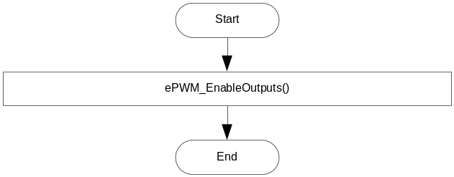

Store Local copy of outputs into Module Outputs
None

Per: ePWM2_Trns2

Design Rationale
Implements the "ePWM gate outputs are disable if function leaves operate state" portion of ES-34E "Motor Control Configuration Override" subfunction. Function executes on exiting mode OPERATE

Store Module Inputs to Local copies
None

Processing of function
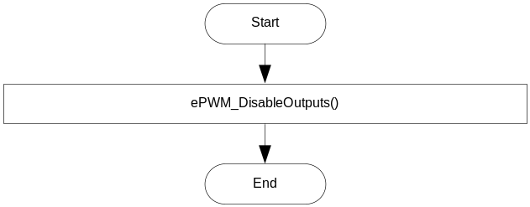

Store Local copy of outputs into Module Outputs
None

Known Limitations With Design

None

UNIT TEST CONSIDERATION

None

Appendix
None

